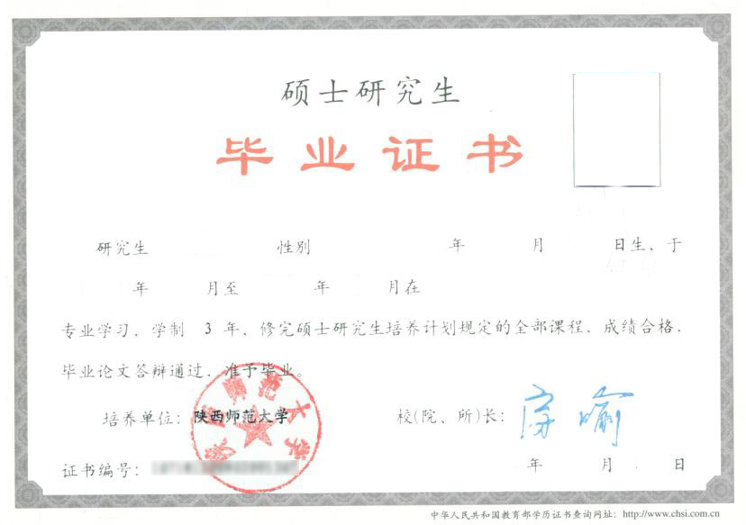

**CERTIFICATE FOR GRADUATION**

**SHAANXI NORMAL UNIVERSITY**

Certificate No: 10718********

This is to certify that Li Ming, male, born on April 21, 1980, majoring in Computer Science and Technology of this university from September, 2009 to July, 2012, has successfully fulfilled all curriculums of the three-year postgraduate program of study , and passed the examinations. Hereby He is allowed to graduate.

President: Fang Yu

Shaanxi Normal University

July 1, 2012

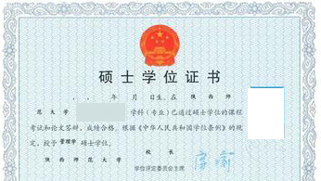

**CERTIFICATE FOR THE MASTER'S DEGREE**

Certificate No: 10718**********

This is to certify that Li Ming, male, born on April 21, 1980, majoring in Computer Science and Technology of this university, has successfully fulfilled all curriculums of the three-year postgraduate program of study, and passed the examinations.

Upon the examination and verification in conformity with the Regulations of Academic Degrees in the People's Republic of China, heis thereby granted the Master of Science Degree.

Chairman of the Degree Senate: Fang Yu

Shaanxi Normal University

July 1, 2012