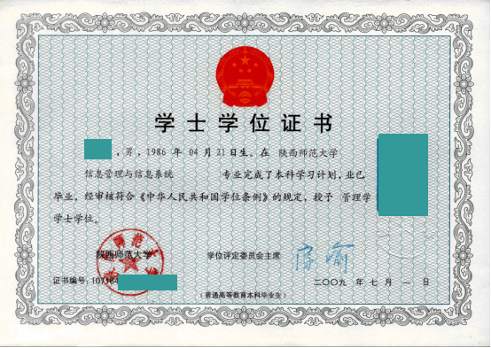

**CERTIFICATE FOR THE BACHELOR'S DEGREE**

Certificate Number:10718********

This is to certify that Li Ming, male, born on April 21, 1986, majoring in Information Management & Information System of this university, has successfully fulfilled all curriculums of undergraduate program of study, and passed the examinations.

Upon the examination and verification in conformity with the Regulations of Academic Degrees in the People's Republic of China, he is thereby granted the Bachelor of Management degree.

Chairman of the Degree Senate: Fang Yu

Shaanxi Normal University

July 1, 2009

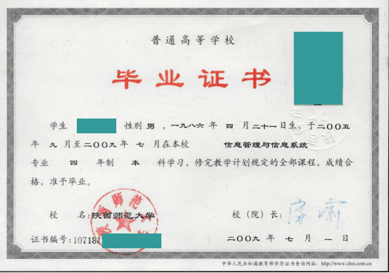

**CERTIFICATE FOR GRADUATION**

**SHAANXI NORMAL UNIVERSITY**

Certificate Number: 10718**********

This is to certify that Li Ming, male, born on April 21, 1986, majoring in Information Management & Information System of this university from September 2005 to July 2009, has successfully fulfilled all curriculums of the four-year undergraduate program of study, and passed the examinations. Hereby he is allowed to graduate.

President: Fang Yu

Shaanxi Normal University

July 1, 2009